ME5073: Marine Robotics
USV Project Report
SNo | Name | Roll No | Course/Branch
1 | ANGAJALA NIKHIL CHAITANYA | me25resch11003 | ME
2 | MUHAMMED SHANSHAD | ME25MTECH11012 | ME
3 | Rehbar Khan | Me25mtech11015 | ME
4 | Raju Santhani | SM24MTECH12001 | SM
5 | Hari keerthan | ME23BTECH11028 | ME
6 | Jashwanth | ME23BTECH11014 | ME
7 | Sai Dhanush | AI23BTECH11021 | AI
8 | Dinesh | AI23BTECH11019 | AI
9 | Ajay | AI23BTECH11011 | AI

Built at
ASTRAM Lab,
Department of Mechancial and Aerospace Engineering,
Indian Institute of Technology, Hyderabad



Contents
Chapter 1: Design of USV 3
CAD Model 3
Specifications 3
3D Printing 3
Water-tight Joints 5
Drag Calculation and Propulsion Speed 6
Chapter 2: Electronics Architecture 7
Chapter 3: Integration of Teranis and Mission Planning 10

Chapter 1: Design of USV

CAD Model
Autodesk Fusion 360 was used to develop the CAD model.
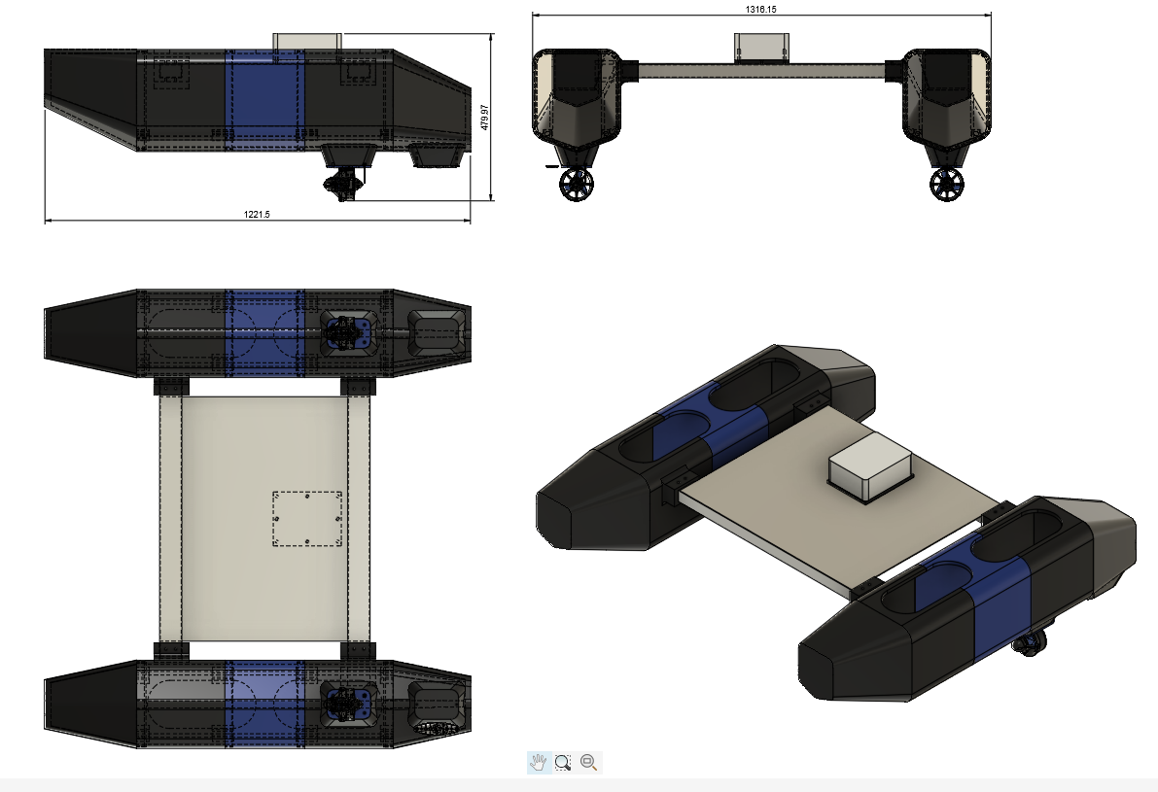
Fig.1. CAD Model: All Views

Specifications
Length | 1221 mm
Width | 1318 mm
Kerb Weight | 16 kg
Waterline Weight Capacity | 64 kg
Propulsion | 2 x T200 Thrusters (Blue Robotics)
Controller | Pixhawk X7 Pro+
Transmitter | Teranis Q X7 with R9M Receiver
Mission Planner | ArduPilot Mission Planner

3D Printing
Material | Numaker’s PETG-HS (from Robu.in)
Walls/Perimeters | 4
Infil Pattern | Gyroid
Infil Density | 20%
Printed Using | Bambu Lab H2S
Filaments Consumed | 14 kg (Pitch Black)  4 kg (Translucent Blue)

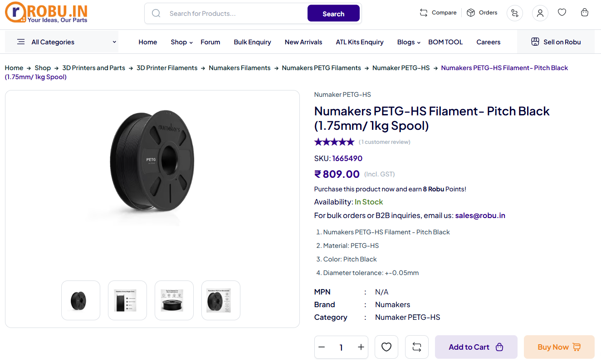
Fig.2. Numakers PETG-HS Filament used for 3D printing the hull sections
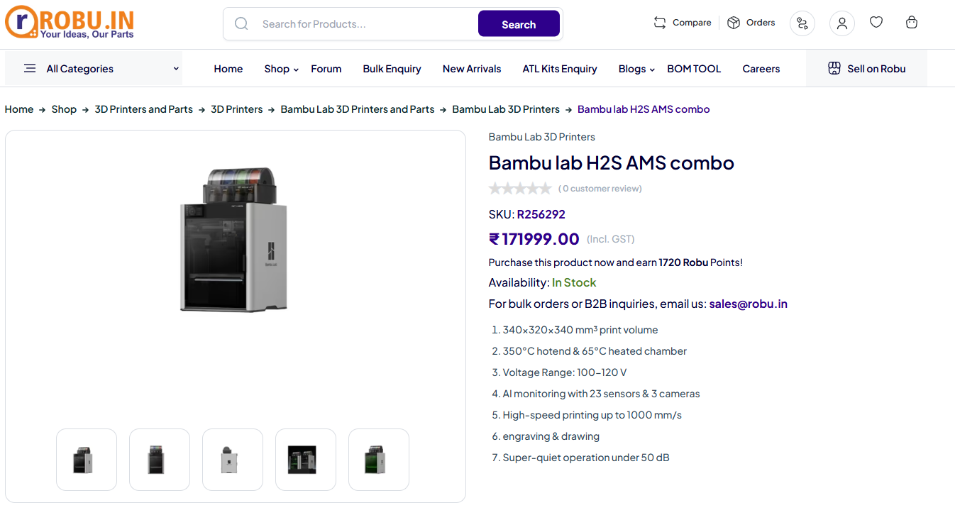
Fig.3. BambuLab H2S 3D prninter used for 3D printing the hull sections

Water-tight Joints
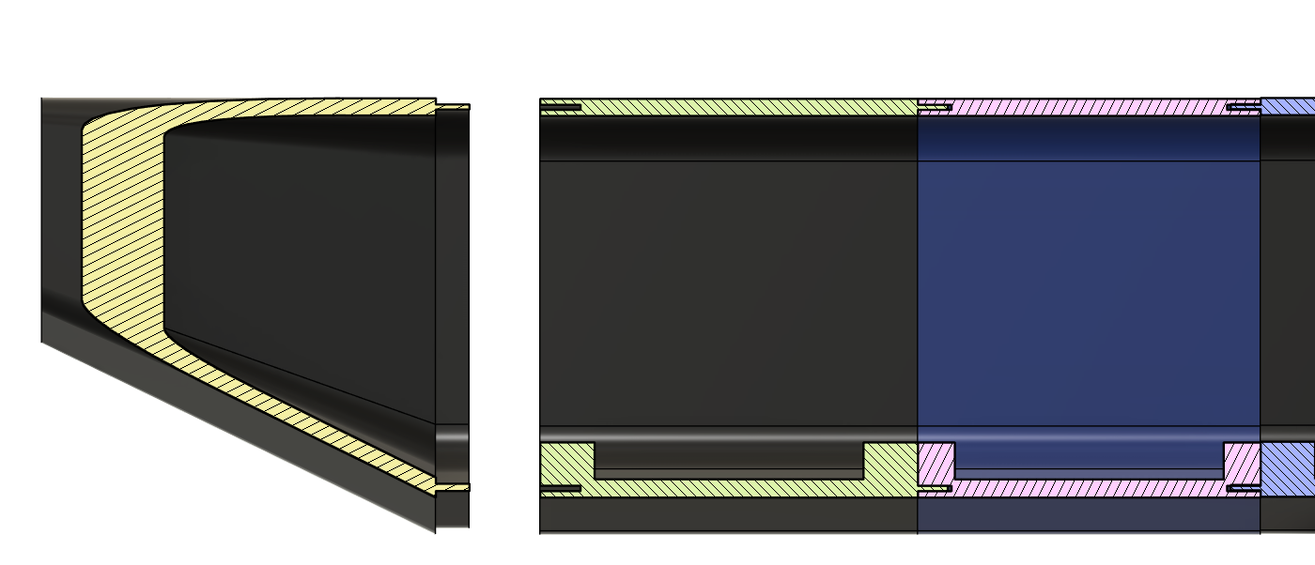
Fig.4. Lip and Groove type joints
Later after assembly, the Dow Dowsil 789 (Silicone weatherproof Sealant) is applied at the joint seams and allowed to cure for 24 hours to make it water-proof.
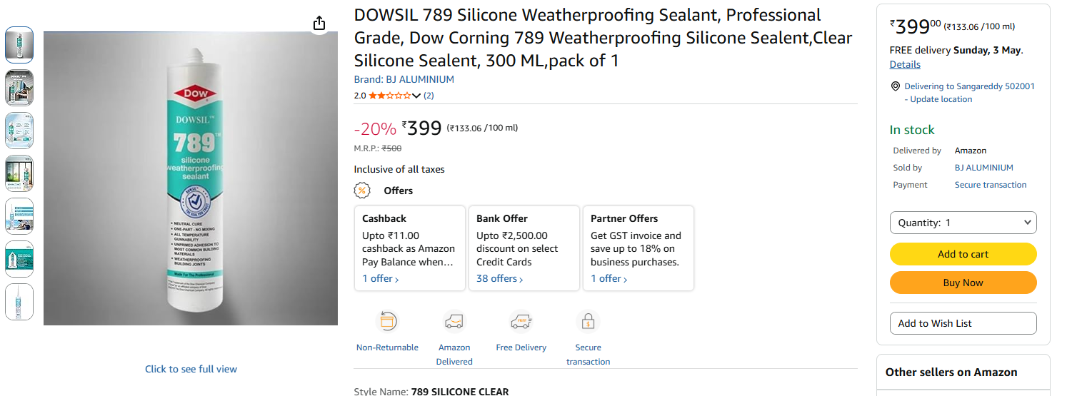
Fig.5. Weatherproof silicone sealant used

Drag Calculation and Propulsion Speed
Drag coefficient and Thruster rating of the boat is estimated by taking the reference values from BlueBoat ROV of BlueRobotics
Parameter | BlueBoat | Current USV
Top Speed (V) | 3 m/s | -
Thrusters | 2x M200 | 2x T200 (M200 equivalent performance)
Thrust Rating of each thruster | 5 kgf @ 16 V | 4.55 kgf @ 14 V (4S)
Wetted Surface Area (Aw) | 0.7 m^2 | 1.0 m^2 (from CAD Model)
Density of water (Rho) | 1000 kg/m^3 | 1000 kg/m^3
Estimated Drag Coefficient | Ct  = 2*5*9.81/(1/2*Rho*Aw*V^2)  = 0.031 | Ct = 0.043 (40% more considering that the shape of the hull is box like and not in a proper V shape)
Top Speed (Calculated) | - | 2 m/s

Chapter 2: Electronics Architecture
Pixhawk X7 Pro+ is a ready-made quadcopter flight controller that can be configured and customized for building and controlling various ROVs like rovers, surface boats, airplanes, robots etc that comes with built-in accelerometer, gyrometer, IMU and compass for dynamic stabilization, although the dynamic stabilization is not required for a boat.
The reason for using PixHawk X7 Pro+ is that it can be configured for mission planning with opensource mission planning interfaces like the ArduPilot (using GPS waypoints).and can be connected with radio transmitters and receiver modules available in the market, like the FrSky Teranis X7 remote and R9M Receiver.
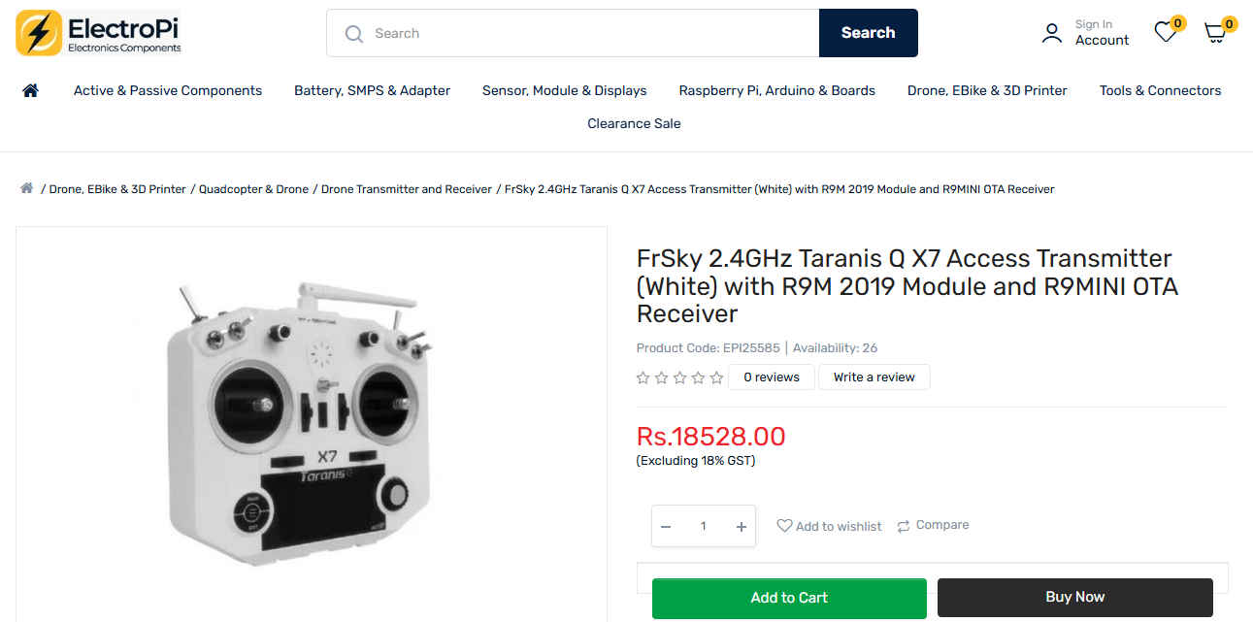
Fig.6. FrSky’s Taranis Q X7 remote controller
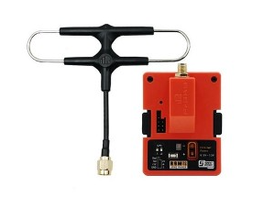
Fig.7. R9M Mini Transmitter (install on the back side of Taranis Q X7)
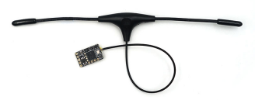
Fig.8. R9M Mini Receiver (Connect to the Pixhawk board)
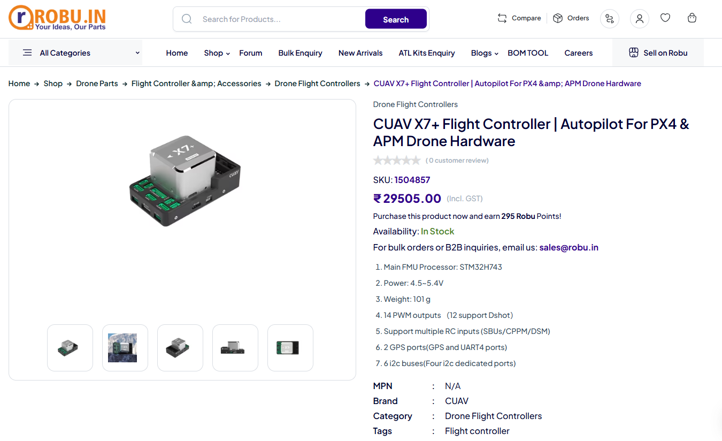
Fig.9. Pixhawk X7 Pro flight controller (CUAV brand)

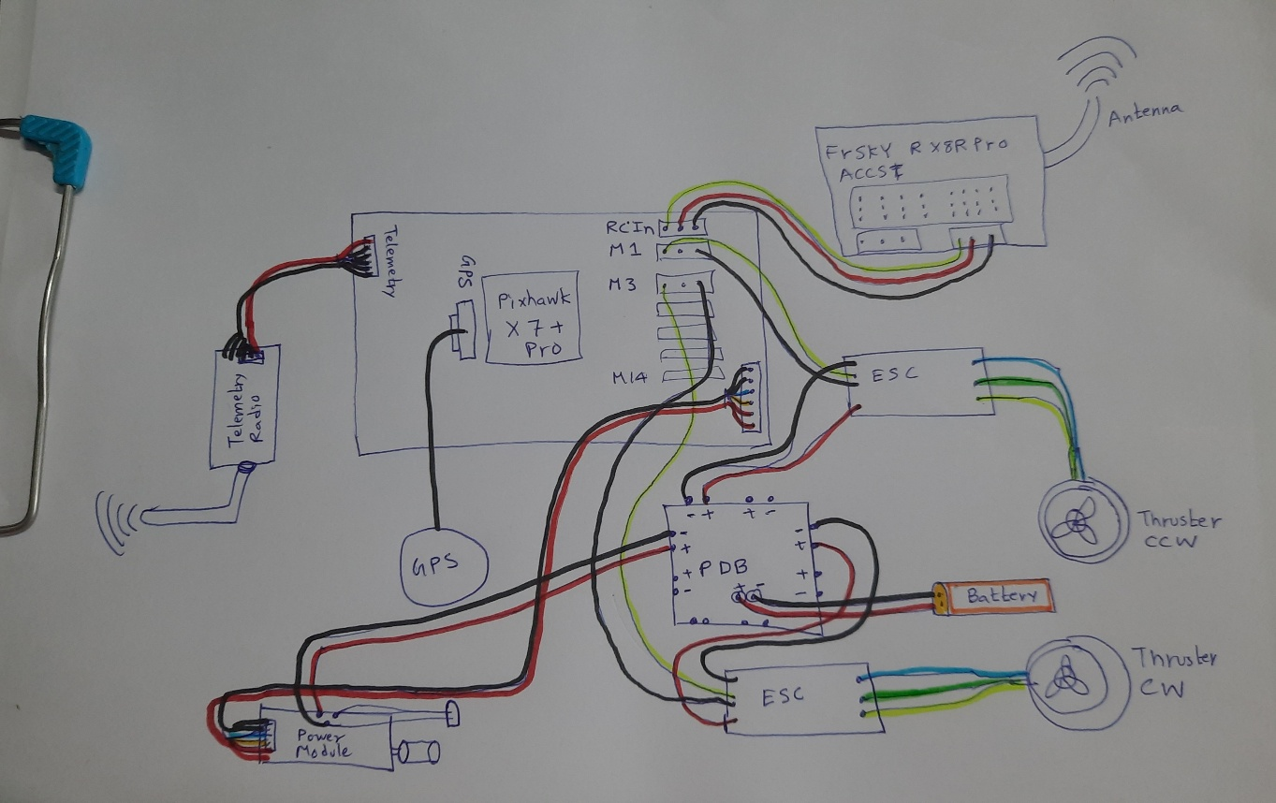
Fig. 8. Schematic of the connections

Chapter 3: Integration of Teranis and Mission Planning


